WEBCAM FAMILY MASS AT 10.00am - SUNDAY 8th November 2020
32nd SUNDAY IN ORDINARY TIME
From www.yellowwallsparish.ie FOR THE PARISHES OF
KINSEALY, MALAHIDE, PORTMARNOCK AND YELLOW WALLS.

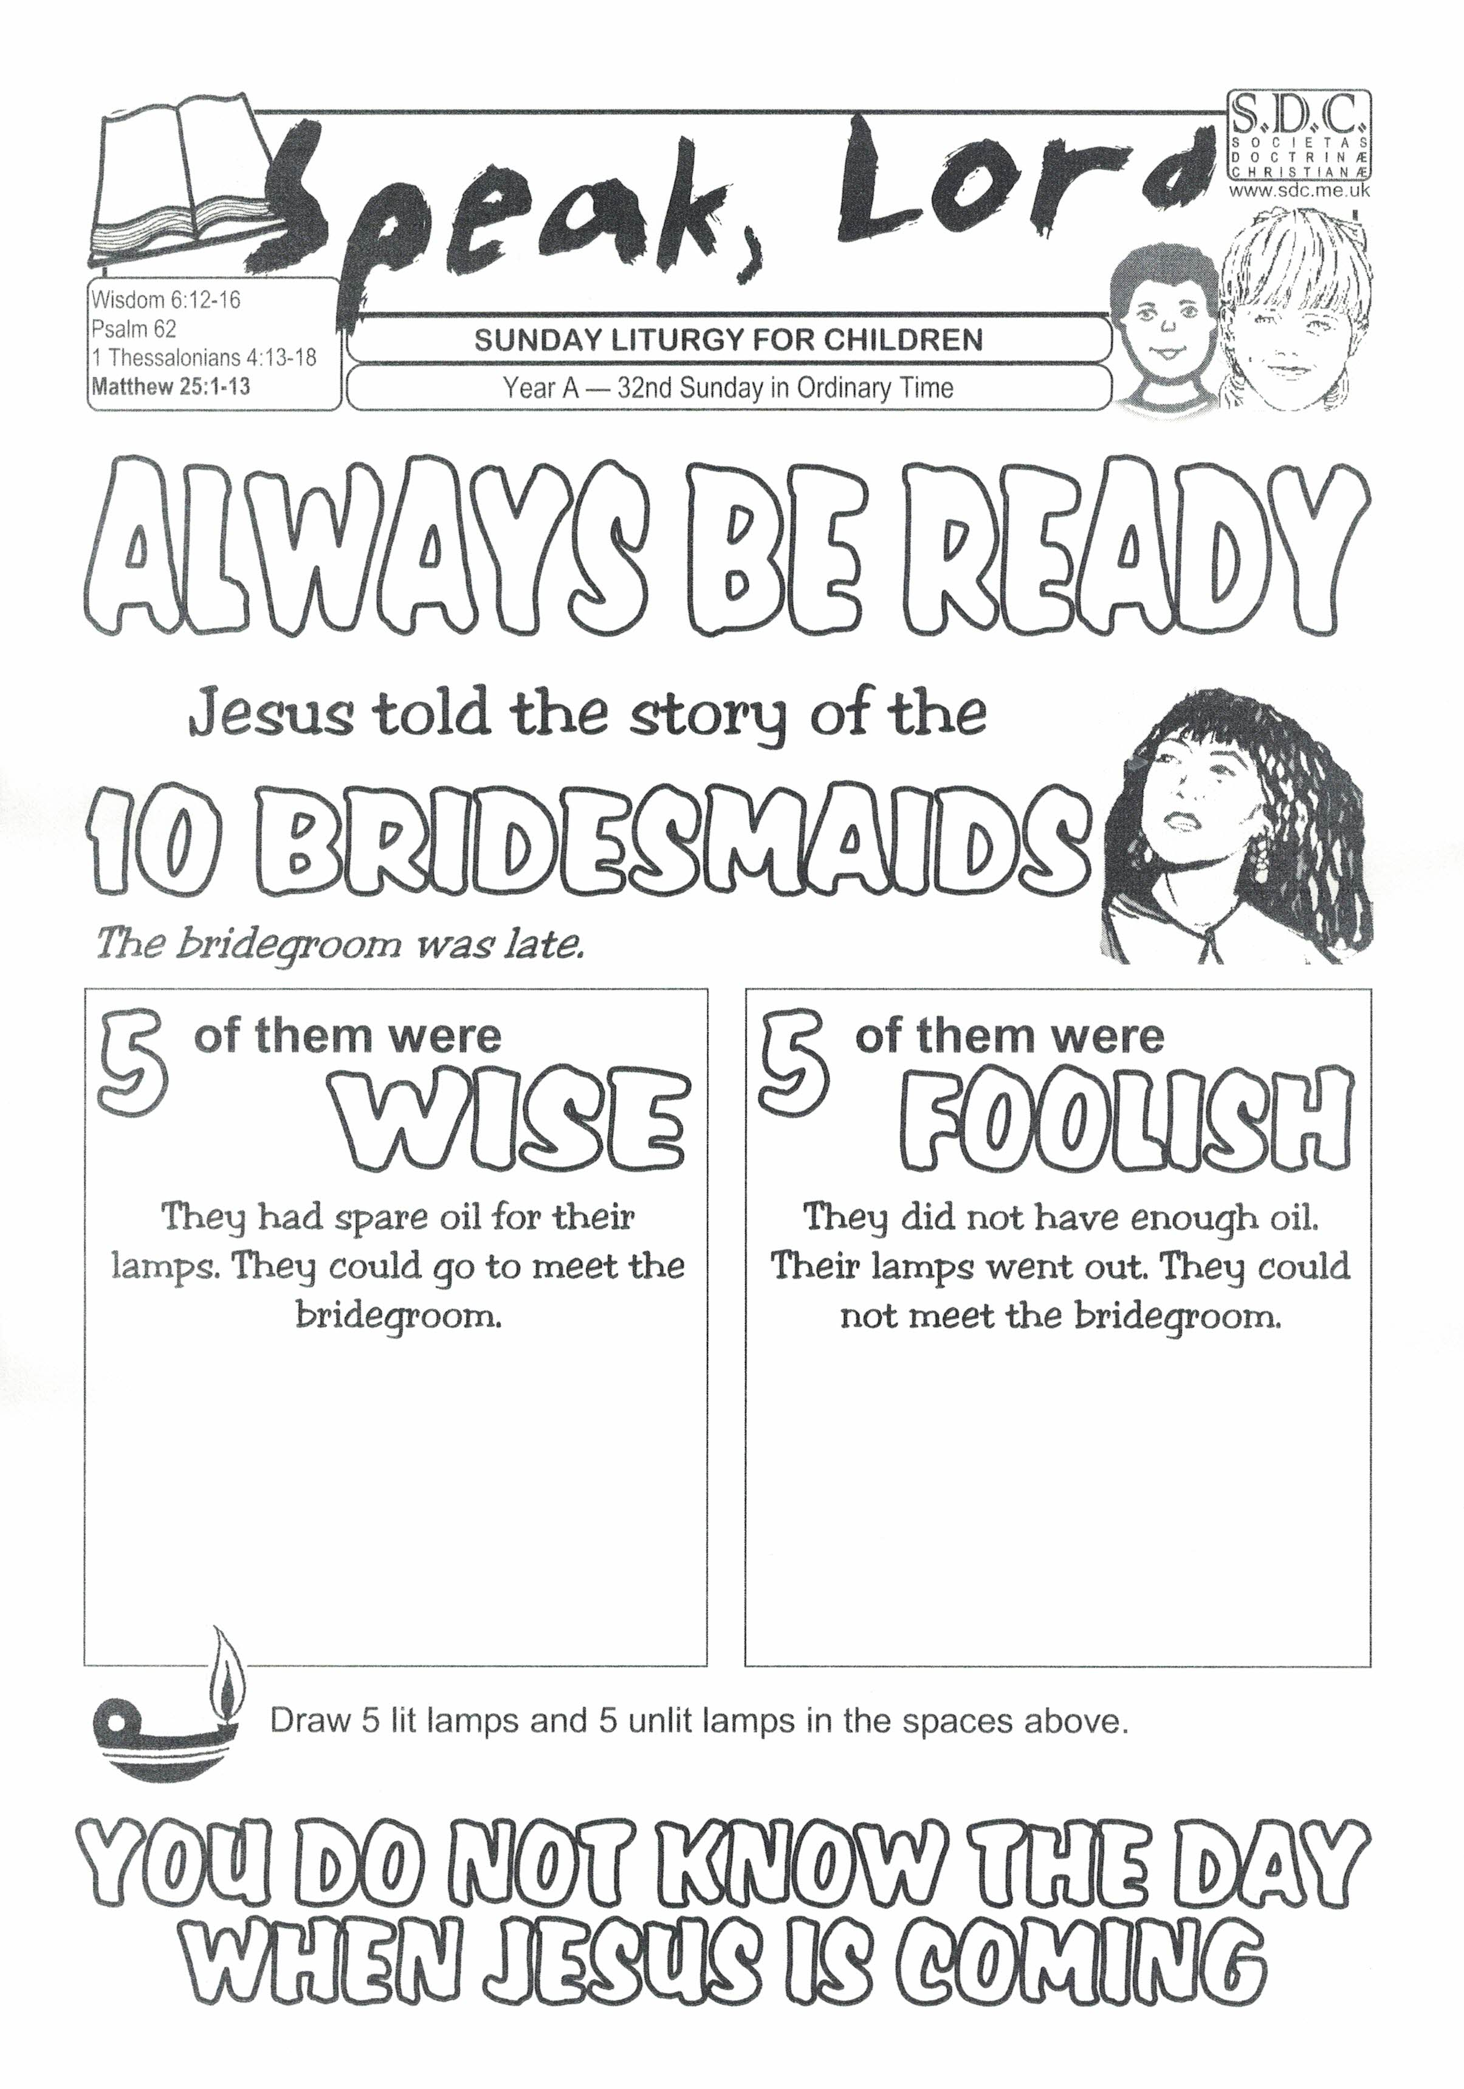
The Five Wise Bridesmaids and the Five Foolish Bridesmaids
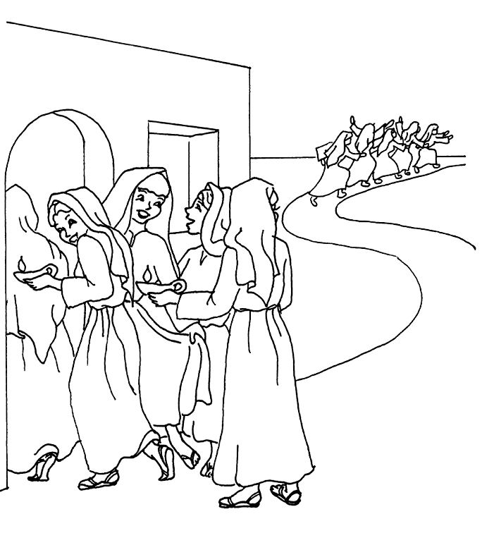

Five Ways I can Prepare for Confirmation

ENTRANCE HYMN: GIVE ME JOY IN MY HEART

Give me joy in my heart, keep me praising,
Give me joy in my heart, I pray,
Give me joy in my heart keep me praising,
Keep me praising till the break of day.

Sing Hosanna (X3).. to the King of Kings
Sing Hosanna (X3)...to the King.

Give me peace in my heart, keep me resting, etc.

Give me love in my heart, keep me serving, etc.

Good morning and welcome to our Mass. We welcome all the boys and girls from our local schools of St. Nicholas of Myra, St. Oliver Plunkett School, Scoil Mearnóg, St. Helen’s and John Paul II, St. Andrew’s and Educate Together who are looking in at our Mass this morning with their parents and families.
We also welcome everybody who is watching this Mass on the webcam from Yellow Walls Church here in Malahide.
Today we hear about Wisdom and choosing God’s Way. Wisdom is one of the gifts of the Holy Spirit so wisdom is a special gift from God. The gift of wisdom is not about being able to know and understand complicated maths or science. It is about seeing things as God sees them and being always ready to give of our best and to live as God wants us to live. It is about knowing how to make the right decisions, the right choices in our lives, and it is about being able to learn from our mistakes or even from the mistakes of others. The first reading speaks of Wisdom as a person who can easily be found by anyone who wants to be wise. God is always ready to give us this gift. In the Gospel Jesus tells a story about how some people can be wise and make good decisions and some can be unwise or very foolish.

PRESENTATION OF THE SYMBOLS

In our sacred space this morning we have:
- A table covered with a Green cloth. The colour green, for hope and life, is used during the church season of Ordinary time when we listen to stories of Jesus, his mission and his teachings.

- A candle – the symbol of Jesus who is the light of the world and who always shines even in the darkness.

- A Bible – we learn all about Jesus from reading the Bible and we use some of the readings from it at Mass.

- A prayer card – when we say our prayers we can talk to Jesus and listen to him.

- Sylvester Bear who is at Mass today representing all the boys and girls who cannot be here

- A Dove which is a symbol of Wisdom - one of the Seven Gifts of the Holy Spirit.

- An Oil Lamp – in the Gospel story today some of the bridesmaids bring extra oil for their lamps. They prepare well and make wise and good decisions.

SORRY PRAYERS
Jesus, for the times we were lazy and did not give of our best,
We are sorry. LORD HAVE MERCY.

Jesus, for the times we deliberately did things that we knew were not right,
We are sorry, CHRIST HAVE MERCY.

Jesus, for the times we chose not to be kind and helpful to someone, We are sorry. LORD HAVE MERCY.

GLORY BE TO THE FATHER AND TO THE SON AND TO THE HOLY SPIRIT, AS IT WAS IN THE BEGINNING, IS NOW AND EVER SHALL BE, WORLD WITHOUT END, AMEN.

A READING FROM THE BOOK OF WISDOM,
Wisdom shines brightly, and she is easily seen by all who love her and search for her. Wisdom hurries to meet everyone who wants to be wise. If you get up early and search, you will easily find her at your front door. Keep your mind on Wisdom, and you will be very wise. Keep thinking about her, and all of your worries will soon disappear. Wisdom goes around searching for those who deserve her. She meets them along the road and stays in their thoughts.

THE WORD OF THE LORD.

ALL SAY: THANKS BE TO GOD

BE NOT AFRAID
You shall cross the barren desert,
but you shall not die of thirst.
You shall wander far in safety,
tho’ you do not know the way.
You shall speak your word
in foreign lands, and they will understand
You shall see the face of God and live.
Be not afraid, I go before you always
Come follow me, and I will give you rest.
Blessed are your poor,
for the kingdom shall be theirs
Blessed are you that weep and mourn,
for one day you shall laugh
And if wicked men insult and hate you
all because of me,
blessed, blessed are you!

Be not afraid, I go before you always
Come follow me, and I will give you rest.

Alleluia, Alleluia! Stay awake and stand ready,
because you do not know the hour when the Son of Man is coming
Alleluia!

PRIEST: THE LORD BE WITH YOU
ALL SAY: AND WITH YOUR SPIRIT

PRIEST: A READING FROM THE HOLY GOSPEL ACCORDING TO MATTHEW
ALL SAY: GLORY TO YOU, O LORD.
Jesus told his disciples this story about the kingdom of Heaven: “The kingdom of heaven is like what happened one night when ten bridesmaids took their oil lamps and went to a wedding to meet the groom. Five of the bridesmaids were foolish and five were wise. The foolish ones took their lamps, but no extra oil. The ones who were wise took along extra oil for their lamps. The groom was late arriving, and the girls became drowsy and fell asleep. Then in the middle of the night someone shouted, ‘Here’s the groom! Come to meet him!’ When the girls got up and started getting their lamps ready, the foolish ones said to the others, ‘Let us have some of your oil! Our lamps are going out.’ The girls who were wise answered, ‘There’s not enough oil for all of us! Go and buy some for yourselves’ “While the foolish girls were on their way to get some oil, the groom arrived. The girls who were ready went into the wedding, and the doors were closed.”

THE GOSPEL OF THE LORD

ALL SAY: PRAISE TO YOU, LORD JESUS CHRIST.

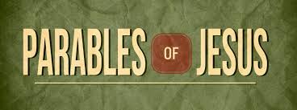

PRAYER OF THE FAITHFUL

- For ourselves, that we may use the gift of Wisdom to always know and do the right and the best thing at all times,
LORD HEAR US.

- For our families. Help us to stay best friends with each other,
LORD HEAR US

- For the many people who help each one of us every day of our lives, even the people we do not see. We ask God to bless them all,
LORD HEAR US.

- For the pupils who have yet to make their Confirmation. May they keep growing in the wisdom of God as we continue to look forward to their special day whenever it happens. We also look forward to First Holy Communion Day.
LORD HEAR US.

- For all the people who do not like the dark days of winter, especially those who are alone and lonely and who find it even more difficult this year because of covid-19
LORD HEAR US.

- For all the people at home or in hospital who are not well and for all who have covid-19. May they be blessed with your healing peace and love,
LORD HEAR US.

We remember all those who have died in our parishes………

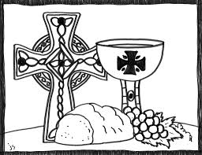

OFFERTORY HYMN : TAKE OUR BREAD
Take our bread, we ask you,
Take our hearts, we love you,
Take our lives, oh Father,
We are yours, we are yours.
Yours as we stand at the table you set,
Yours as we eat the bread
our hearts can't forget.
We are the signs of your life with us yet;
We are yours, we are yours.

Take our bread, we ask you,
Take our hearts, we love you,
Take our lives, oh Father,
We are yours, we are yours.

Priest: Pray, my brothers and sisters that my sacrifice and yours may …………….

ALL SAY: May the Lord accept the sacrifice at your hands, for the praise and glory of his name, for our good and the good of all his holy Church.

ALL SAY: Holy, Holy, Holy Lord, God of hosts.
Heaven and earth are full of your glory.
Hosanna in the highest.
Blessed is he who comes in the name of the Lord,
Hosanna in the highest.

SUNG: He is Lord, He is Lord
He is risen from the dead and He is Lord
Ev’ry knee shall bow ev’ry tongue confess
that Jesus Christ is Lord

OUR FATHER IS SUNG (With Actions)

Our Father, who art in heaven,
Hallowed be Thy name;
Thy kingdom come; Thy will be done
on earth as it is in heaven.
Give us this day our daily bread;
and forgive us our trespasses as we forgive offenders,
Hallowed be thy name;
and lead us not into temptation,
Hallowed be thy name,
but deliver us from evil,
Hallowed be thy name,
For thine is the kingdom, the power and the glory
For ever and ever, Amen. X 2

PRAYER FOR PEACE Lord Jesus Christ, who said to your Apostles:
Peace I leave you, my peace I give you;
look not on our sins but on the faith of your Church,
and graciously grant her peace and unity
in accordance with your will.
Who live and reign for ever and ever, Amen.

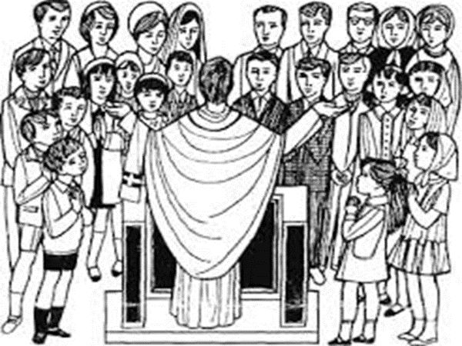

ALL SAY: Lamb of God, you take away the sins of the world; have mercy on us
Lamb of God, you take away the sins of the world; have mercy on us
Lamb of God, you take away the sins of the world; grant us peace.

Priest says: Behold the Lamb of God, behold Him who takes away the sins of the world. Blessed are we to be called to the supper of the Lamb

ALL SAY: Lord, I am not worthy that you should enter under my roof,
but only say the word and my soul shall be healed.

PRAYER BEFORE HOLY COMMUNION.

Lord Jesus, come to me,
Lord Jesus, give me your love.
Lord Jesus, friend of children, come to me.

Lord Jesus,
you are my Lord and my God.
Praise to you, Lord Jesus Christ

ACT OF SPIRITUAL HOLY COMMUNION
Jesus, I believe you are really present in the Eucharist.
I love you with all my heart.
I want you to be in my heart and soul all the time.
Please be with me in spirit at this time,
even though I cannot receive you in Holy Communion.
Keep me always close to you just as you promised. Amen.

COME HOLY SPIRIT

Holy Spirit sent by God
to make our spirit free,
Light the darkness in our lives
and help us clearly see
Holy Spirit by your presence
give us strength to share
Share the message of God’s Word,
to love, be kind and care

Come Holy Spirit, come
be the light that shines in our darkness.
Come Holy Spirit, come
be the fire that burns in our hearts
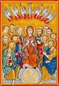
Holy Spirit, teach us wisdom,
teach us right from wrong
Teach us how to love our neighbour,
help us to belong
Holy Spirit, show us how
to sing God’s Name, rejoice
Praise God’s wonder here on earth,
united with one voice.
Come Holy Spirit, come….

Holy Spirit move our hearts
and let your bright fire burn.
Be our guide, there at our side,
when to our God we turn.
Holy Spirit move our hands,
our feet, our mouths, our eyes.
May our actions speak your Word
forever in our lives.
Come Holy Spirit, come…..

PRAYER AFTER COMMUNION

Lord Jesus, I love and adore you.
You’re a special friend to me.

Welcome, Lord Jesus, o welcome.
Thank you for coming to me.

Thank you, Lord Jesus, O thank you
for giving yourself to me.
Make me strong to show your love
wherever I may be.

I’m ready now, Lord Jesus,
To show how much I care.

I’m ready now to give your love
at home and everywhere. Amen

BLESSING: Priest: Our Mass is ended, let us go in peace All say: THANKS BE TO GOD

RECESSIONAL HYMN – O WHEN THE SAINTS

Oh, when the saints go marching in,
Oh, when the saints go marching in,
Oh, how I want to be in that number,
When the saints go marching in.

Oh we are trav'ling in the footsteps
Of those who've gone before,
And we'll all be reunited,
On a new and sunlit shore.

Oh, when the saints go marching in,
Oh, when the saints go marching in,
Oh, how I want to be in that number,
When the saints go marching in.
Oh when the sun begins to shine,
Oh when the sun begins to shine,
Lord, how I want to be in that number,
When the sun begins to shine.

Oh, when the saints go marching in,
Oh, when the saints go marching in,
Oh, how I want to be in that number,
When the saints go marching in.

Oh, when the moon begins to glow,
Oh, when the moon begins to glow
Oh,, how I want to be in that number,
When the moon begins to glow. (Chorus)

