WEBCAM FAMILY MASS AT 9.45am - SUNDAY 27th JUNE 2021
THIRTEENTH SUNDAY OF ORDINARY TIME
From www.malahideparish.ie FOR THE PARISHES OF
KINSEALY, MALAHIDE, PORTMARNOCK AND YELLOW WALLS

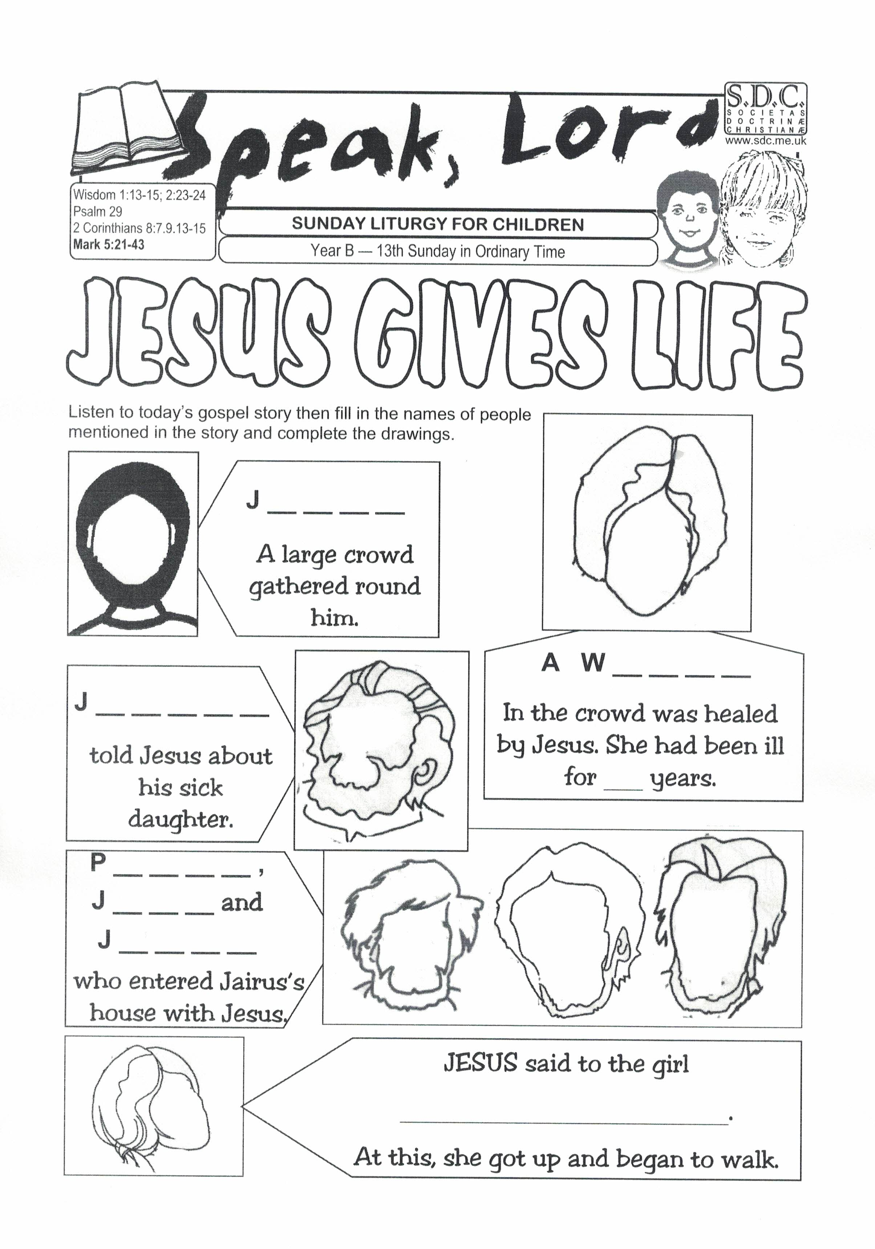

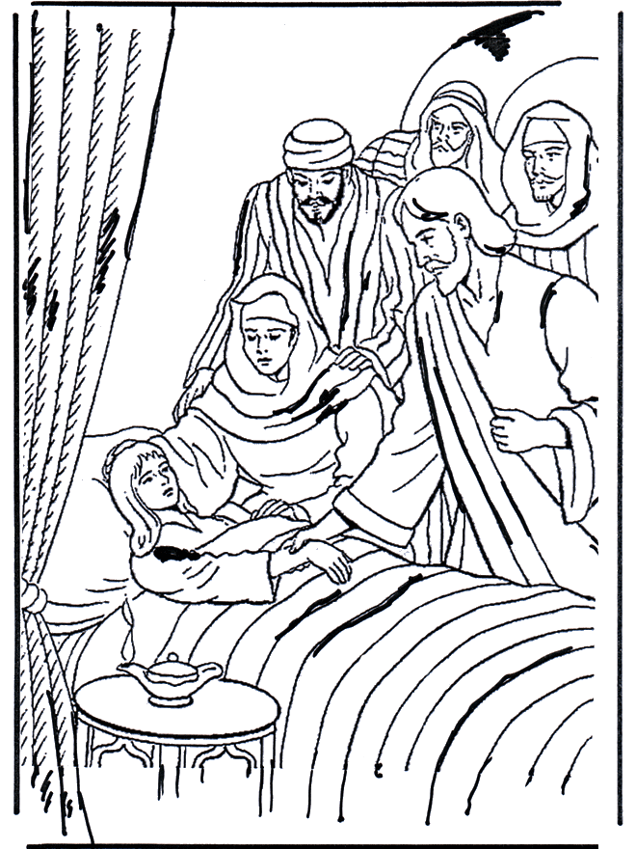

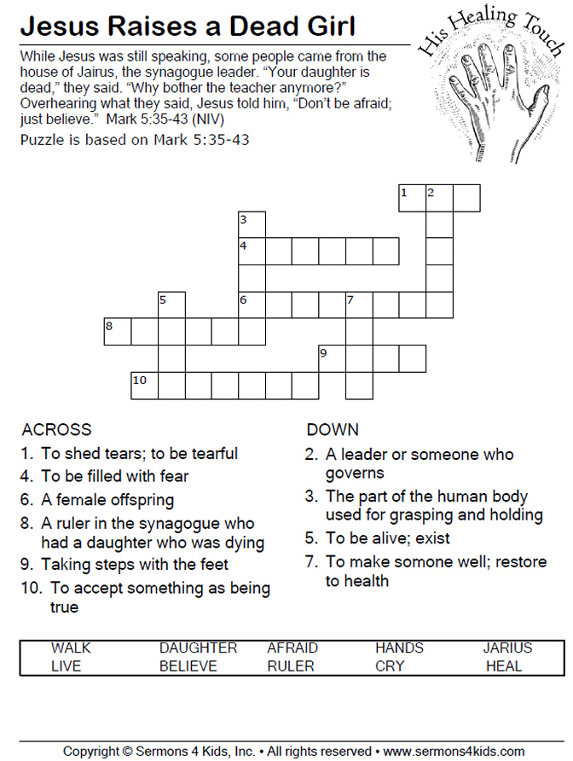
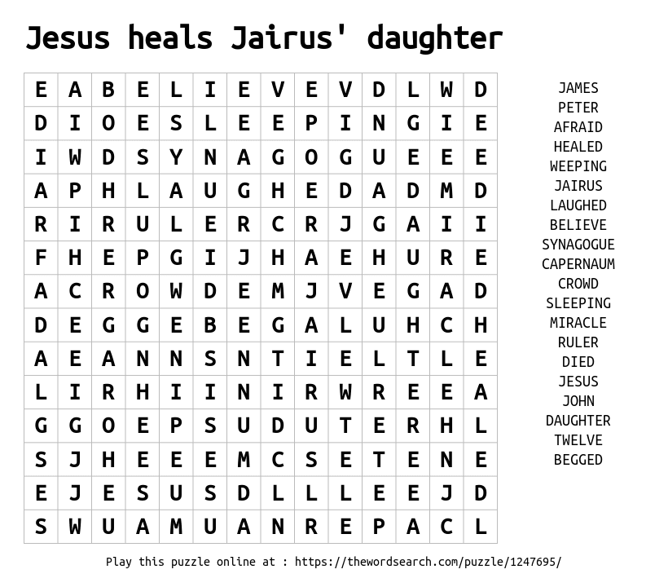
ENTRANCE HYMN: GIVE ME JOY

Give me joy in my heart,
keep me praising,
Give me joy in my heart, I pray,
Give me joy in my heart
keep me praising,
Keep me praising till the break of day.

Sing Hosanna (X3) .. to the King of Kings
Sing Hosanna (X3)...to the King.

Give me hope in my heart,
keep me loving, etc.

WELCOME
Good morning and welcome to Mass. We also welcome the boys and girls from our local schools together with their parents and families who are linking into the Mass this morning.
Today is the Thirteenth Sunday in Ordinary Time. In the Gospel today Jesus brings a young girl, Jairius’ daughter, back to life – this is another miracle story about the power Jesus had to bring the caring love of God to those around him. The good news is that Jesus also brings that same caring love of God to all of us. Listen after the Gospel to hear more.

PRESENTATION OF SYMBOLS
In the Sacred Space here, we have copy of the Bible and a prayer card. The Bible is so important to us because the Bible contains all the stories that Jesus told and helps us to find out more about the wonderful things he did. The prayer card is a reminder that we stay close to Jesus when we pray to him.
As usual Sylvester Bear is here and he has with him our special symbol for today – a picture of the joy that Jesus brings through the caring love of God.

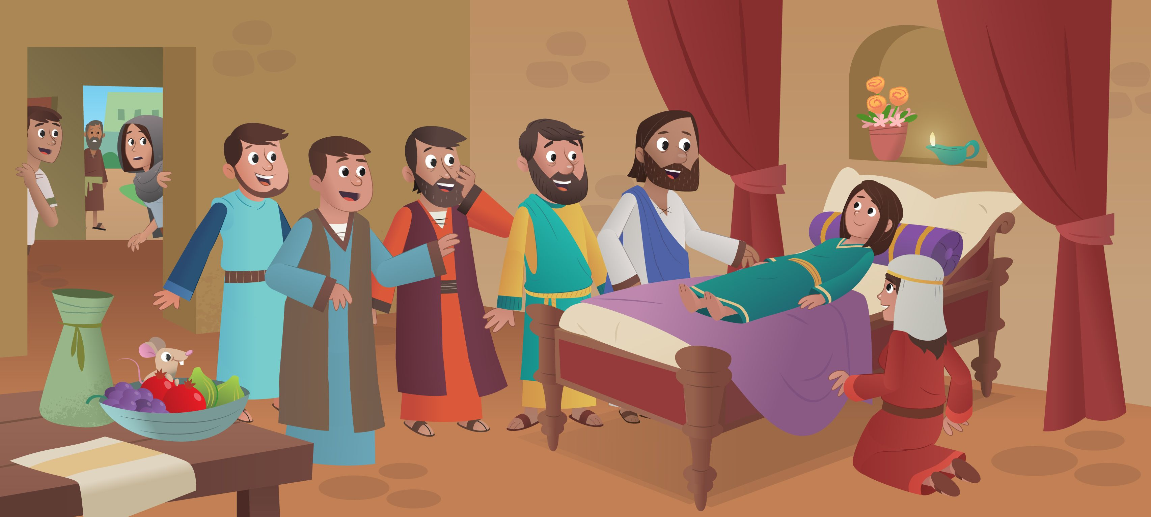
SORRY PRAYERS
Jesus, for the times we were not kind and helpful, we are sorry. Lord, have mercy. All: LORD HAVE MERCY

Jesus, for the times we did not tell the truth, we are sorry. Christ, have mercy. All: CHRIST HAVE MERCY

Jesus, for times we were hurtful to someone else, we are sorry. Lord, have mercy. All: LORD HAVE MERCY.

GLORY BE TO THE FATHER, AND TO THE SON, AND TO THE HOLY SPIRIT AS IT WAS IN THE BEGINNING, IS NOW AND EVER SHALL BE, WORLD WITHOUT END, AMEN.

OPENING PRAYER.

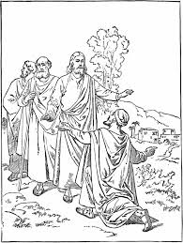

A READING FROM THE FIRST LETTER OF JOHN:
My dear friends, we must love each other. Love comes from God, and when we love each other, it shows that we have been given new life. We are now God’s children, and we know him. God has shown his love for us when he sent his only Son into the world to give us life.
THE WORD OF THE LORD

ALL: THANKS BE TO GOD

PSALM: MY SHEPHERD IS THE LORD

My shepherd is the Lord,
He tends all my needs.
By quiet streams
he plants a dream
Of peace and love for me.
He shepherds me.

Sometimes when I’m afraid,
Sad and all alone,
You make my tears disappear
With your touch of joy.
You shepherd me.

You give me food to eat,
Bless me every day.
You give me rest
as your guest
Forever in your home.
You shepherd me.

My shepherd is the Lord,
He tends all my needs.
By quiet streams
he plants a dream
Of peace and love for me.
He shepherds me.

GOSPEL ACCLAMATION: Alleluia, Alleluia! Your words are spirit, Lord, and they are life, you have the message of eternal life. Alleluia!

PRIEST: THE LORD BE WITH YOU
ALL SAY: AND WITH YOUR SPIRIT
PRIEST: A READING FROM THE HOLY GOSPEL ACCORDING TO MARK (5:21-24, 35-43)
ALL SAY: GLORY TO YOU, O LORD.
Jesus got into the boat and crossed Lake Galilee. Then, as he stood on the shore, a large crowd gathered around him. The person in charge of the Jewish meeting place was also there. His name was Jairus, and when he saw Jesus, he went over to him. He kneeled at Jesus feet and started begging for help. He said, “My daughter is about to die! Please come and touch her, so she will get well and live!” Jesus went with Jairus. Many people followed and kept crowding around.
A little while later, some men came from Jairus’ home and said, “Your daughter has died! Why bother the teacher anymore?” Jesus heard what they said, and he said to Jairus, “Don’t worry. Just have faith!” Jesus did not let anyone go with him except Peter and the two brothers, James and John. They went with Jairus and saw the people crying and making a lot of noise. The Jesus went inside and said to them, “Why are you crying and carrying on like this? The child is not dead. She is just asleep.” But the people laughed at him. After Jesus had sent them all out of the house, he took the girl’s mother and father and his three disciples and went to where she was. He took the twelve-year-old girl by the hand and said, “Talitha, koum!” which means, “Little girl, get up!” The girl got up and started walking around. Everyone was greatly surprised. Then he said, “Give her something to eat.”
THE GOSPEL OF THE LORD

ALL SAY: PRAISE TO YOU, LORD JESUS CHRIST.

REFLECTION
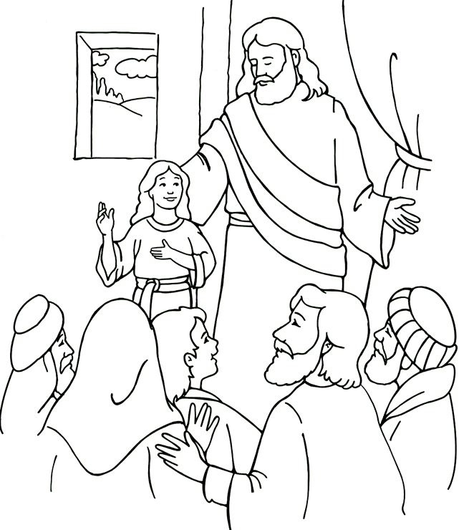
PRAYER OF THE FAITHFUL

- That we will be true followers of Jesus by living lives of love, kindness and generosity. Lord, hear us. LORD GRACIOUSLY HEAR US.

- For peace in our hearts, in our homes and in all the troubled parts of the world. Lord, hear us. ALL: LORD GRACIOUSLY HEAR US.

- For all who have lost a family member that Jesus may bring healing and peace to them. Lord hear us. ALL: LORD GRACIOUSLY HEAR US.

- For all the boys and girls who are still preparing for their Confirmation and First Holy Communion later this year. May they continue to prepare well and look forward to their special day. Lord, hear us. LORD GRACIOUSLY HEAR US.

- We pray for all who are sick with covid-19 and all other illnesses. We pray for all who are caring for the sick or worried about them. Send your healing love upon them all. Lord, hear us. LORD GRACIOUSLY HEAR US.

- For all those who have died in our parishes, and in Yellow Walls Parish this week we pray for those recently deceased. May their souls and the souls…………Lord, hear us. LORD GRACIOUSLY HEAR US.

OFFERTORY HYMN – WE COME TO YOU LORD JESUS

We bring the bread, we bring the wine,
we bring them now to you,
we bring our work, we bring our play,
and everything we do.
We love you, Lord Jesus,
stay with us we pray,
help us to be more
like you each day.

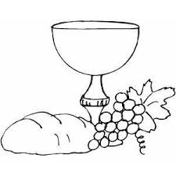
Priest: Pray, my brothers and sisters that my sacrifice and yours may …………….

ALL: May the Lord accept the sacrifice at your hands, for the praise and glory of his name, for our good and the good of all his holy Church.

ALL SAY: ALL: Holy, Holy, Holy Lord, God of hosts.
Heaven and earth are full of your glory.
Hosanna in the highest.
Blessed is he who comes in the name of the Lord,
Hosanna in the highest.

SUNG: He is Lord, He is Lord
He is risen from the dead and He is Lord
Every knee shall bow every tongue confess
that Jesus Christ is Lord.
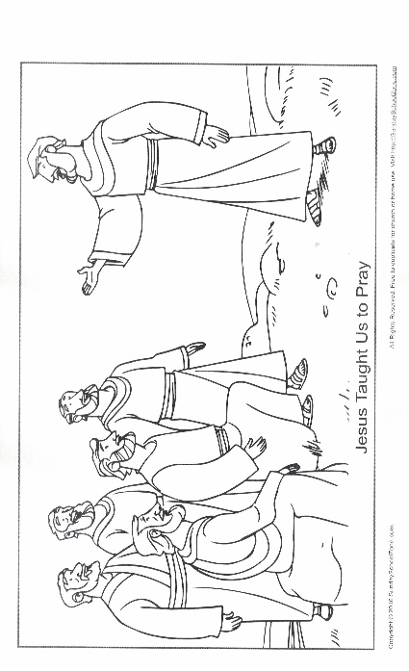
OUR FATHER IS SUNG (With Actions)

Our Father, who art in heaven,
Hallowed be Thy name;
Thy kingdom come; Thy will be done
on earth as it is in heaven.
Give us this day our daily bread;
and forgive us our trespasses as we forgive offenders,
Hallowed be thy name;
and lead us not into temptation,
Hallowed be thy name,
but deliver us from evil,
Hallowed be thy name,
For thine is the kingdom, the power and the glory
For ever and ever, Amen. X 2

PRAYER FOR PEACE: Lord Jesus Christ, who said to your Apostles:
Peace I leave you, my peace I give you;
look not on our sins but on the faith of your Church,
and graciously grant her peace and unity
in accordance with your will;
Who live and reign for ever and ever. Amen.

ALL: Lamb of God, you take away the sins of the world; have mercy on us
Lamb of God, you take away the sins of the world; have mercy on us
Lamb of God, you take away the sins of the world; grant us peace.

PRAYER BEFORE HOLY COMMUNION.

Lord Jesus, come to me,
Lord Jesus, give me your love.
Lord Jesus, friend of children,
come to me.
Lord Jesus,
you are my Lord and my God.
Praise to you, Lord Jesus Christ.

Priest: Behold the Lamb of God, behold Him who takes away the sins of the world. Blessed are we who are called to the supper of the Lamb.

ALL: Lord, I am not worthy that you should enter under my roof, but only say the word and my soul shall be healed.

ACT OF SPIRITUAL HOLY COMMUNION (for those at home)
Jesus, I believe you are really present in the Eucharist.
I love you with all my heart.
I want you to be in my heart and soul all the time.
Please be with me in spirit at this time,
even though I cannot receive you in Holy Communion.
Keep me always close to you just as you promised. Amen

Covid-19 Announcement (ii) - Followed by Distribution of Holy Communion

COMMUNION HYMN : LAY YOUR HANDS GENTLY UPON

Chorus
Lay your hands gently upon us,
Let their touch render your peace,
Let them bring your
forgiveness and healing,
Lay your hands gently, lay your hands.

You were sent to free the broken hearted.
You were sent to give sight to the blind.
You desire to heal all our illness.
Lay your hands, gently lay your hands.
Chorus
Lord, we come to you
through one another.
Lord, we come to you in all our need.
Lord, we come to you seeking wholeness.
Lay your hands, gently lay your hands.

Chorus
Lay your hands gently upon us,
Let their touch render your peace,
Let them bring your
forgiveness and healing,
Lay your hands gently, lay your hands.

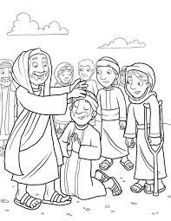
PRAYERS AFTER HOLY COMMUNION

Lord Jesus, I love and adore you.
You’re a special friend to me.

Welcome, Lord Jesus, o welcome.
Thank you for coming to me.

Thank you, Lord Jesus, O thank you
for giving yourself to me.

Make me strong to show your love
wherever I may be.

I’m ready now, Lord Jesus,
To show how much I care.

I’m ready now to give your love
at home and everywhere. Amen.

FINAL BLESSING

Priest: Our Mass is ended, let us go in peace

All: THANKS BE TO GOD

Covid-19 Announcement (iii) - Followed by Final Hymn

FINAL HYMN – GO NOW IN PEACE

Go now in peace together today.
Jesus is here in a very special way.
Tell all you meet
that he is gentle and kind.
Praise him and love him
in body, soul and mind.

Go in peace! Go in love!
Go in joy ev-’ry girl and boy.
Go in peace! Go in love!
Go in joy ev-’ry girl and boy.
Bring all the love we’ve had here today.
Share it around, don’t let it fade away.
Love one another
as Jesus Christ loves you.
Praise him and love him
in everything you do.

Go in peace! Go in love!
Go in joy ev-’ry girl and boy.
Go in peace! Go in love!
Go in joy ev-’ry girl and boy.

